Consecrate A Fast for the Repentance of The Nation & New York City
August 23rd, 2022

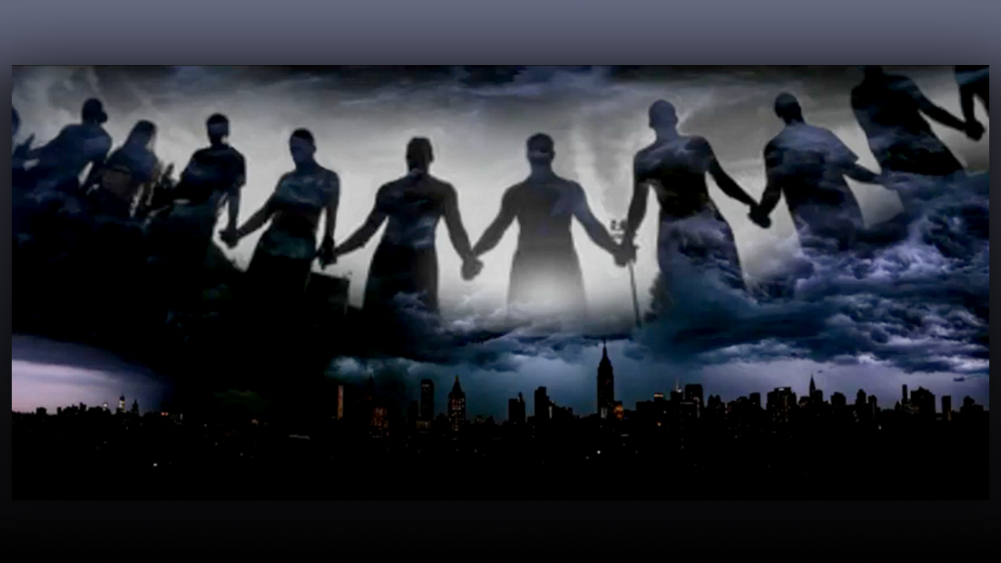
Hello Brothers, Sisters and Heartdwellers family. The Lord is calling us to consecrate days of fasting and prayer again, now for our nation and specifically, New York City. I had pulled a Rhema the day before,

Proverbs 14:32 When calamity comes, the wicked are brought down, but even in death, the righteous seek refuge in God. (And at the bottom it said), “Pray against a national event!”

Then I had a dream the following night where I saw team officers in some building, coming towards a wall — they had guns loaded and pointed... They began shooting at the wall and I could see inside the walls were also men — 6 or 7 of them — also in swat militant uniforms shooting back at them. The wall crumbled revealing the men they were fighting [against] and those inside the wall died, and all fell on the floor. Then the scene changed to a man in a swat militant uniform with his face uncovered being escorted by the police, also in a swat uniform, walking down some steps outside. He was smirking I then had a knowing [that] they had planted a bomb and he was the main culprit however he had 6 or 7 people he had used as puppets to do the dirty work. Those were the ones who died. I felt as though the bomb did go off, but it didn’t do nearly as much damage as they intended because they were captured. I just found it weird they were all wearing the same uniform yet fighting each other. I could only tell who the bad guys were in the dreaming by the knowing of Holy Spirit who gave me understanding.

Then [in] the second half of the dream I was in a room, a hospital room of some kind and I saw on a chair this clear capsule with clear liquid inside. I had a knowing that it was a plasma capsule. It was pretty big, the size of an infant baby, and was in a chair on top of some soft cloth that was holding it. A man, with a doctor’s garment, was sitting close to it. I then saw a screen like a TV explaining to me what the capsule was and the benefits of it. It was something that would be planted or inserted in the body and could expand. One of the benefits was it could retain more pee so people wouldn’t have to go to the bathroom as often. I thought that was weird and then I had a knowing that they were trying to encourage everyone to take this capsule, or have it inserted in their body and that this was a new world order initiative to condition people for the mark.

More scenes happened in the dream but that was the most relevant. I then felt led to pull a Rhema and one said,

Jeremiah 36
Baruch, the scribe of Jeremiah
“Consecrate a Fast for the Repentance of the nation & declare My word”

Immediately I knew it was about the dream. It was from the Lord and very serious. So, after receiving Holy Communion, I began writing.

Good morning Lord, what’s on your heart? You gave me a Rhema to consecrate a fast and declare repentance for our nation. It’s the dream you gave me — is it then, a warning?

Jesus began,

“My beloved one I know you have been hurting, come and rest your weary head on My heart.”

As an aside,
Jesus is so sweet and tender. Although I was coming to him with the concern of the dream he was rather concerned with the pain in my heart. There has been a soul who has been a bit difficult with some of the Lord’s directives I have given them which caused me to doubt what the Lord is telling me to do and also [to be] saddened by their attitude — amongst other crosses [that] I have been carrying —— and just trying to preserver through it all. However, Jesus, being in my heart knows the pain it has caused and is addressing that first, like the good God He is.

“You have been carrying various crosses that I have permitted. I am here to strengthen you, Beloved, as you continue to bear these crosses manfully. Do not give up, all your sacrifice, all your tears, and all the oppression you have endured for love of Me are bearing much fruit.

“No longer question yourself with directives I give you for a soul. I will continue to affirm your motherhood over and over again to those whom I have entrusted under our care. They will come to respect and honor My leading through you, Beloved. Don’t allow the devils to berate you any longer with lies or insecurity concerning whom I have called you to be. You are called to call people to holiness that is one of your many missions, and without holiness no man shall see God Hebrews 12:14.

“I am calling those who follow you much, much higher in virtue and integrity. It may seem I am being firm, but I am to ensure their soul is of pristine purity and clean before Me. They may not understand, but they will in time. Holiness has been neglected in this generation, not even taught. I will use your life to show case that and make all to see the various sins within their lives that displease Me, that [are] dismissed as nothing, and their entire misery of who they really are so that they can trust in My mercy. So don’t worry, My beloved one, I am with you and stand beside you. I am pleased with your decisions to follow Me even when it’s difficult. I am your spouse, and we are doing this together.”

Thank you Lord for your kind words, I love you Jesus

“You needed to hear that, Beloved. I want to give you peace so you can begin to move forward.”

Lord [for] the past couple of days, well actually it seems the whole week, I have been hit with an exhaustion I can’t explain. When I have been tired before I have been able to persevere, but it’s like a can’t. It’s like a sleepiness and utter exhaustion I can’t explain. Is this a suffering or is this an assignment from the devils?

Jesus responded,

“It’s both, Beloved, the enemy has been banking on the fact you would give in to these feelings of tiredness to hinder you from the work and tasks I have given you to do. I have permitted it as a suffering so you can offer it to Me, Beloved, but My grace is sufficient for you in your weakness. So rather than give in, Beloved, call upon Me, ask Me for the grace and push forward in the task before you, so you don’t give in to your flesh any longer.”

Okay Lord forgive me and please help me

Jesus continued,

“I am here to do just that.

“Now concerning the state of your nation, it is so very bleak, so very bleak, Beloved. “That is a portion of what Father Ezekiel and the community sufferings have been for. I desire to adhere to My peoples request and forestall WW3, but it looks so very dark, Beloved. We are in need of more prayers and fast offerings. The intel you all have received concerning New York is accurate. That is the city, or should I say, the stage they will use to insight an attack and start WW3. The dream I gave you was to confirm the false flag they now have planned.

“Do not be mistaken New York City is slated for destruction that is a pronounced judgment that cannot be changed, but the timing can. What they intend to do is to cause a bomb to go off and blame it on their enemies, but the enemy is within. Hence in the dream both sides had on the same militant uniform yet playing against each other and even killing one another — sacrificing a few to gain power and control over the whole world. My beloved brides, Satan and his servants are impatience and are anticipating their long-awaited reign, so they will do anything before the appointed time to insight war. Please, I need you to, yet again, pray like never before so this is mitigated and the culprits planning this would be caught instead.

“America is in the throws, on a thin line between life of this nation and death of this nation. I need My people who are called by My name to pray, consecrate a fast and repent for the sins of this nation, the sins of My church, and personal sins as well. Cry out on behalf of those who are still promoting abortion, sexual immorality, pedophilia, sex trafficking, corruption, bribery, and money laundering. Cry out to Me for the sins of the church, of gossip, jealousy, coveting, posturing, favoritism, love of money, and love of the world, and so much more. Cry out to Me in repentance for your own sins, ask Me to expose the hidden secrets, motivations and actions of your heart that grieve Me, and I will show you.

“Get your children to pray alongside you and ask for mercy for your family, yourselves, and this nation. You are in a pivotal hour and so much can change if My people would repent and pray. You have been given authority over your governments and have been commission to pray for them.

1 Timothy 2:1-3
Therefore I exhort first of all, that supplications, prayers, intercessions, and giving of thanks be made for all men, ² for kings and all who are in authority, that we may lead a quiet and peaceable life in all godliness and reverence. ³ For this is good and acceptable in the sight of God our Savior,

“Your prayers change things and so much has been delayed because of them. My desire is to minimize this planned attack, so it doesn’t insight World War Three, but rather expose the wickedness of your governments and the truth of this staged attack. Pray for many to awaken so they don’t fall for it like so many did with the 9/11 attack which was plotted and executed by your very own, President and leaders in the nation. The wickedness of men and the cry of the little ones have come up to the Fathers nostrils to bring judgment upon your land, but I stand at his right side to intercede on your behalf. My brides, intercede with Me seriously and fervently”.

Wow Lord, okay and may I ask, what about the plasma capsule I saw. What is that about?

“This is something that will come out in the near future, Beloved, as they are making headway to tamper more and more with the human body in any way that they can. The more people give themselves over to trusting their bodies to the government the more they will take advantage of providing them all manner of shots, medication and even gadgets to prepare and condition mankind for the mark of the beast. Pray against these things. At the appointed time more understanding will be given to you concerning this capsule. For now my people fast and pray cry out in repentance for your nation. Pray that this false flag attack would be mitigated and exposed so as to not insight war until the appointed time”

That was the end of Jesus’ message.

The Lord then gave me the fast we are to do for these intentions starting Monday August 1st. We are to consecrate ourselves for 7 days eating only rice and drinking water. For those who are not able to fast in this way give to Jesus what you can, He will be grateful and for those who are able to, let’s all come together to really offer this fast seriously before God and bombard heaven to have mercy upon our nation and mercy upon New York City until the appointed time and that the plans of the wicked will be thwarted and exposed. Mother Elizabeth was given beautiful prayer by the Lord, and I will include that every day at 3pm in conjunction with the Divine Mercy chaplet. Let’s get back in to battle soldiers the Lord is calling us.

